Final Project Documentation for Web Publishing

**Prepared by:** Mohammed Makram **Date:12/9/2023.**

1. Project description

Constructing a Web application to allow an editor to manage and communicate with a group of reviewers and authors to publish articles to the website and make the articles available for public readers, also create database to store Users Info and articles, buy servers to carry out the system. we will need PCs with suitable programming language editors, and some course for the developer team if needed.

**II.** Project proposal and backup data (request for proposal, statement of work, proposal correspondence, and so on)

**III.** Original and revised contract information and client acceptance documents

**IV.** Original and revised project plans and schedules (WBS, Gantt charts and network

diagrams, cost estimates, communications management plan, etc.)

1. WBS:

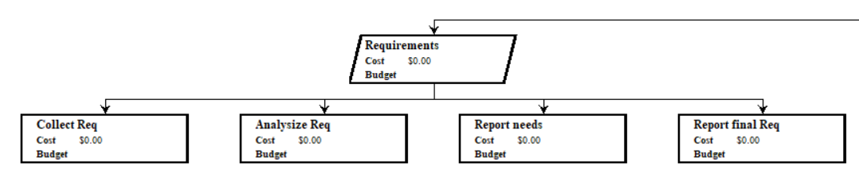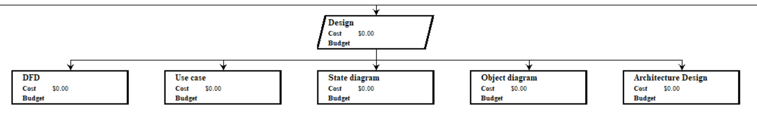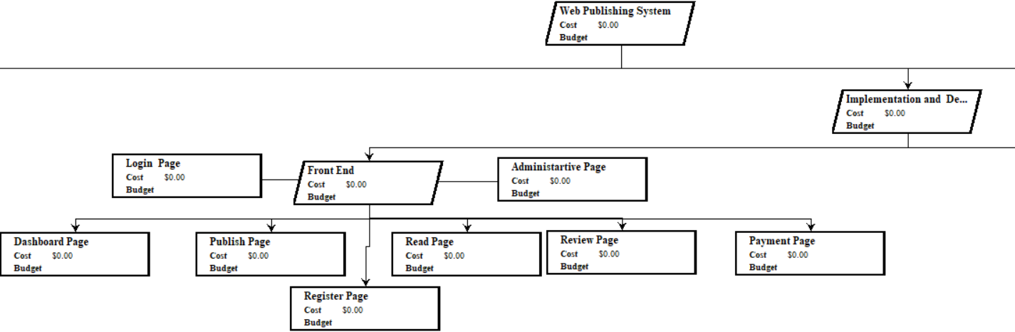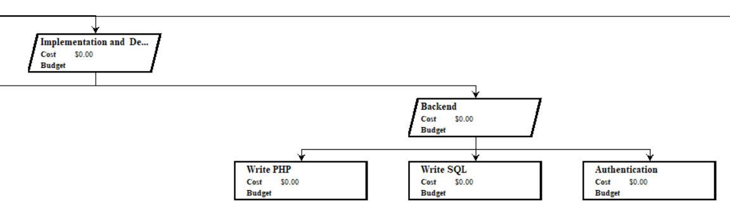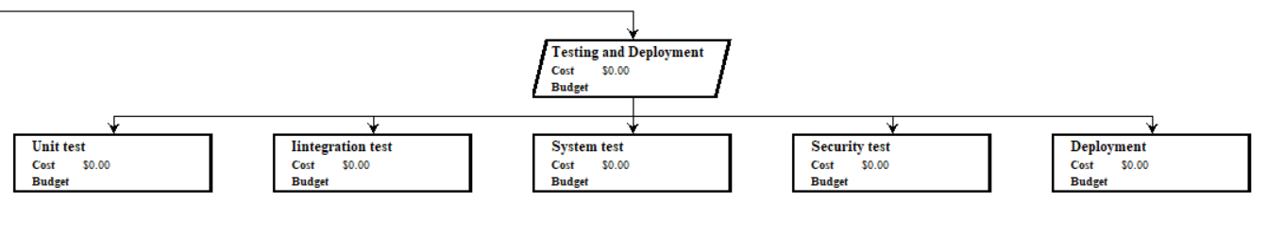

1. Gantt charts:

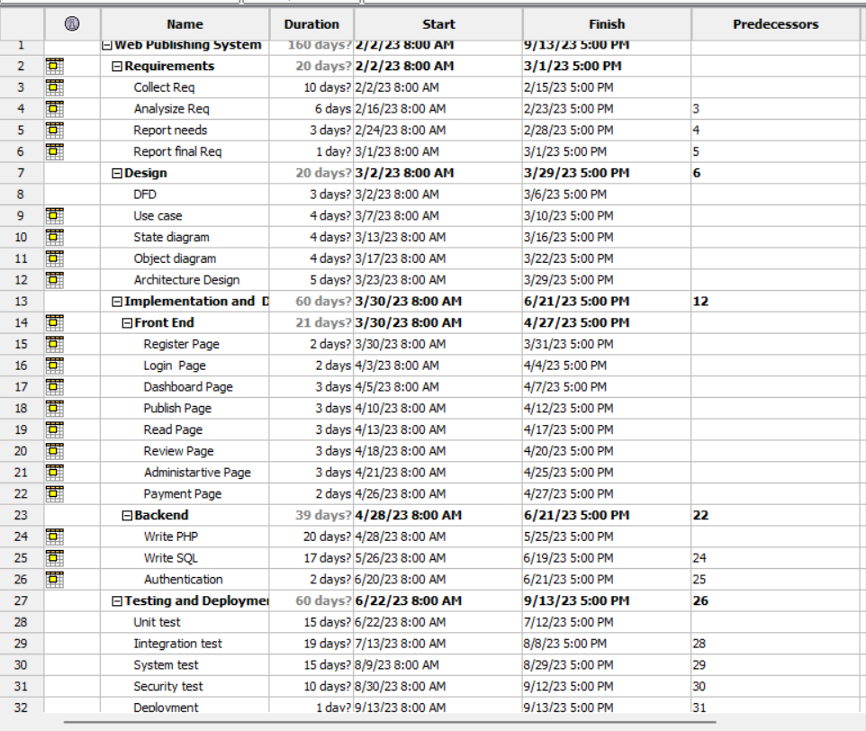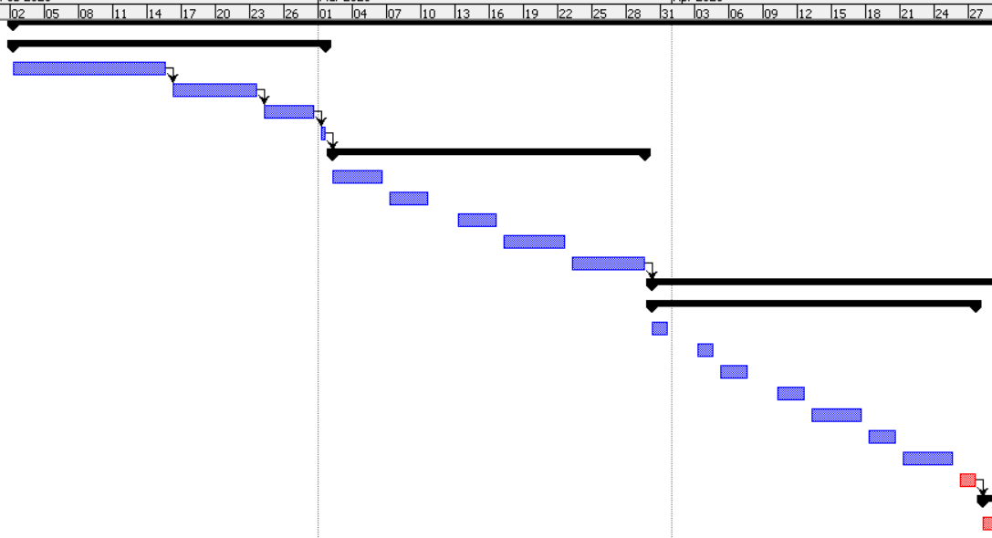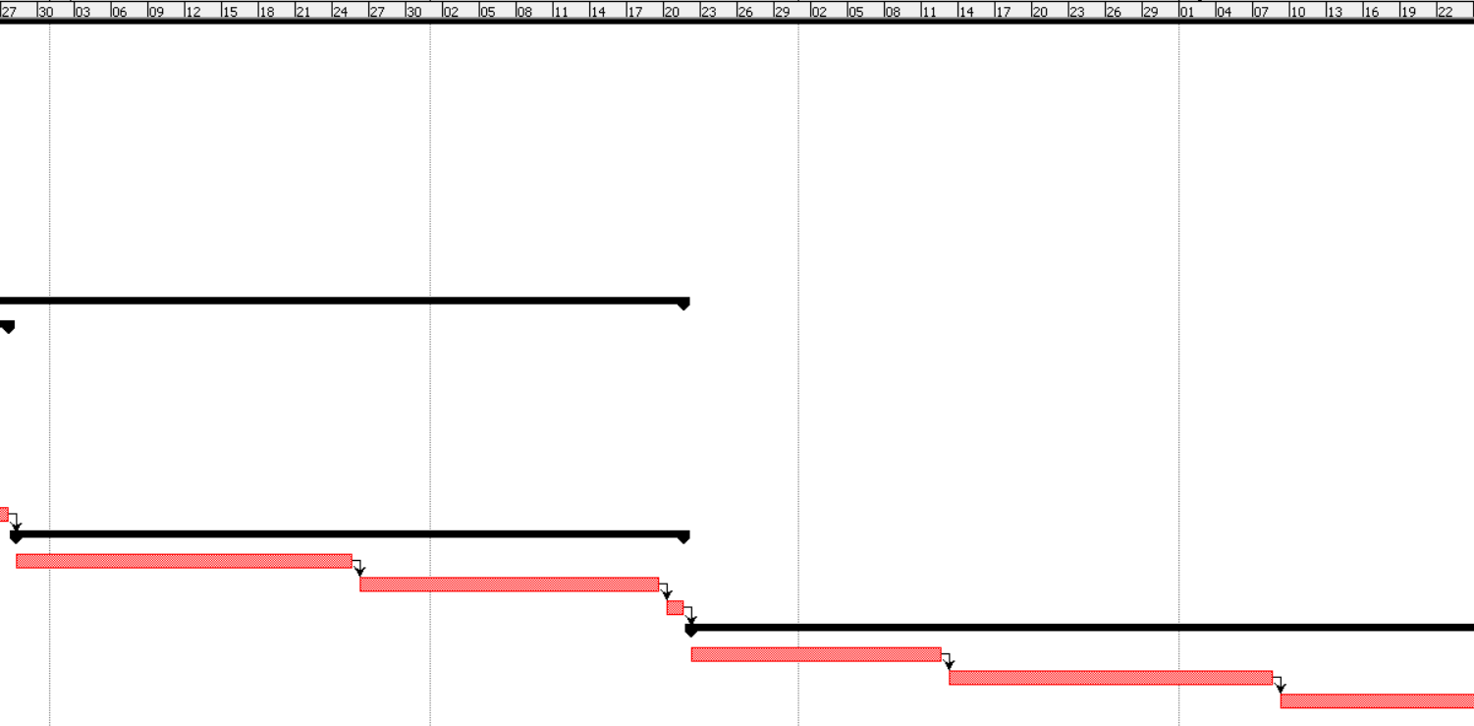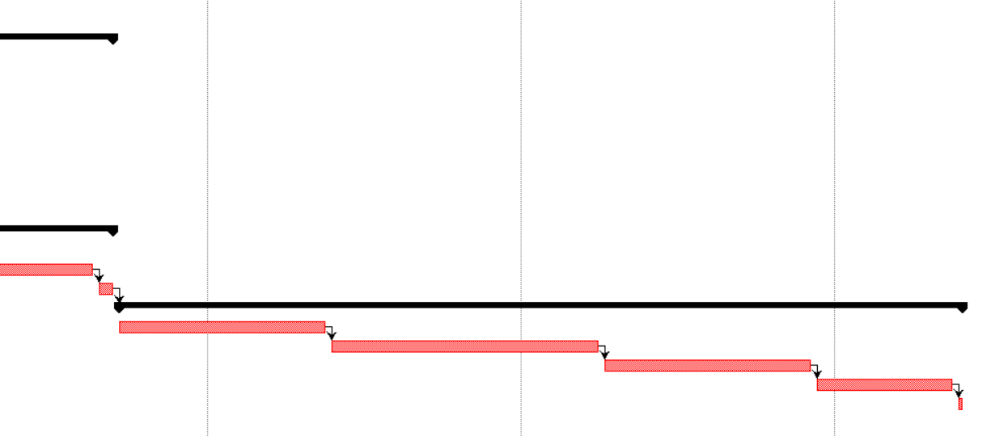

1. Network diagrams

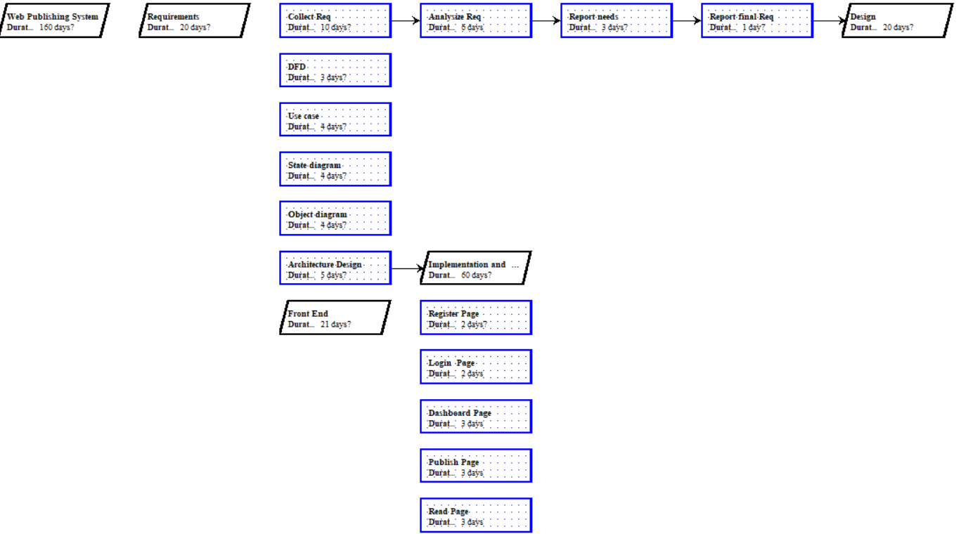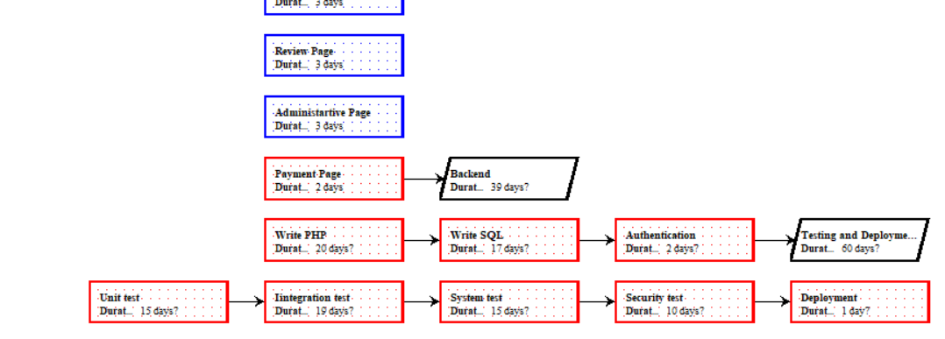

1. cost estimates

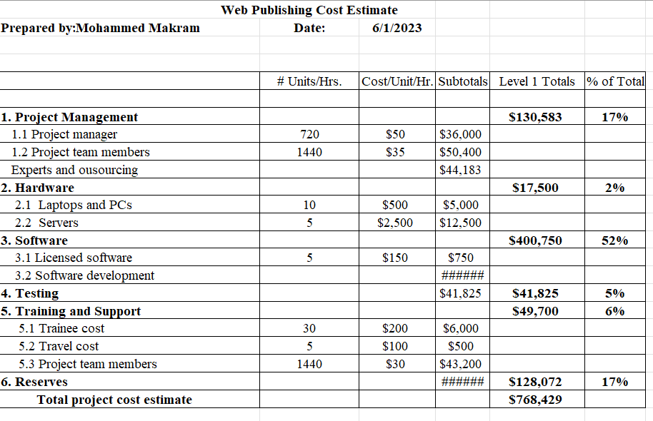

**V.** Design documents

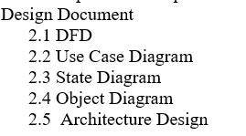

**VI.** Final project report

**VII.** Deliverables, as appropriate

-Final Requirement by the end of first month , Design by the end of second month ,Final Project by the end of the project “8th month “.

**VIII.** Audit reports

**IX.** Lessons learned reports

|  |
| --- |
| **Prepared by: Mohammed Makram**  **Date:11/9/2023.**  **Project Name: Web Publishing**  **Project Sponsor:** Makram Company  **Project Manager:** Makram Mahrous  **Project Dates: start 2/2/2023, end 13/10/2023.**  **Final Budget:**  800,000$ |
| 1. Did the project meet scope, time, and cost goals?   Yes, as it is one of the priorities set to fulfill the success of the project.   1. What was the success criteria listed in the project scope statement?   The project is to be finished by the 13 October with the budget settled and agreed to, and the project will be successful if:-  -For non-functional requirements: system should be able to serve 1000 concurrent active users without degrading in performance, UI should be user friendly, database can store thousands of terabytes of data.  -For functional requirements: Reader should be able to access articles and search for any writer or article by name, editor should be able to update and delete info, articles, writer should be able to post articles and get reviews and finally reviewers should be able to access article to rating them  We have succeed to meet all of our requirements successfully  .   1. Reflect on whether or not you met the project success criteria.   The project will meet the success criteria successfully as everything is working smoothly due to the well managed Work breakdown structure and Resource breakdown structure. However, it will take a longer period to test if the success was met in increasing donations by 20%. As a bonus to the criteria, we were able to complete the project under the estimated budget.   1. In terms of managing the project, what were the main lessons your team learned?   There were many beneficial lessons that were learned while managing this project. First, a lesson was learned with working with stakeholders. It is necessary to communicate and work with stakeholders early in the project and to stay in contact with them. The project started with contact of major stakeholders and clients but failed to stay in contact with them often. This led to scheduling issues. Second, how to deal with resource allocation was learned. It should be defined at the beginning of the project when resources are needed and put in writing that resources will be available for their assigned dates. This was not handled properly in our project, and it caused the project to be behind schedule. Third, we learned how to better manage our budget. We allocated way too much money up front in the project which left us short when coming up on the completion of the project. More money is needed when trying to get the project out the door so less money should be allocated up front.   1. Describe one example of what went right on this project.   The project teamed worked well together and there was key communication with one another. The morale of the team was lifted at every milestone with incentives to keep working hard.   1. Describe one example of what went wrong on this project.   Contact with stakeholders was hard, as they’re not always available so we had hard time trying to stay in contact with them, and that’s one of our biggest lessons learnt. This caused us to have to go back, in some cases, to revise the design of the pages to meet the standards or likes of the stakeholder. This easily could have been avoided with more contact of the stakeholders.   1. What will you do differently on the next project based on your experience working on this project?   We would take some actions differently. Mainly, the lessons that were learned completing this project would help to complete another project with fewer complications. This would again be contacting stake holders early and often. This would also include having our resource allocation defined in writing at the beginning of the project. The management of the budget would be run differently by allocating less money up front and having more money near the completion of the project to help push the product out on the market. One suggestion we may do differently on another project that has not been mentioned to this point, would be to create our work breakdown structure in a different way. We would create it in a deliverable oriented way instead of using the phases of project management. The WBS would be broken down into functional groups so each group would have its own WBS. This would be tested out and then compared to the phase oriented WBS to weigh pros and cons. |

**X.** Copies of all status reports, meeting minutes, change notices, and other written and electronic communications